Definitions and extras

Scale Spaces:
A scale space is relevant when you want to look at a smaller detail on an image. Just like in real life, if you want to single out a single leaf on a tree, it might be a good idea to get rid of some of the other details (leaves, twig, etc.). The only way to do that correctly, without introducing new details, is gaussian blur.
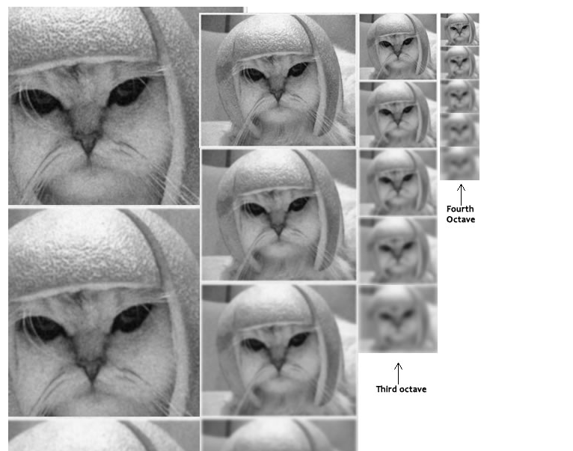
Scale space creation using sift. SIFT blurs out the image repeatedly, then reduces it in half, then repeat.
An Octave is the group of images progressively blurrier in one size. The scale is the amount of blur in the image.

Pyramid
Process used in hog image description (as opposed to local features). The image is resized repeatedly
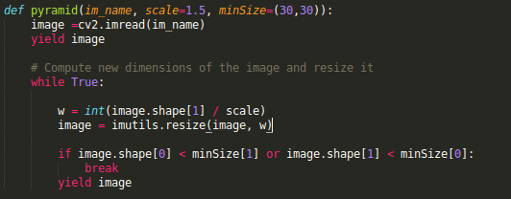
opencv then showcases the images at the press of the 0 key

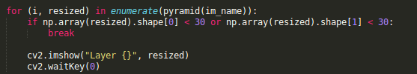
Sliding Windows
Stepsize is how many pixels we are going to skip in x and y direction. In practice, it’s common to use a stepSize of 4 to 8 pixels

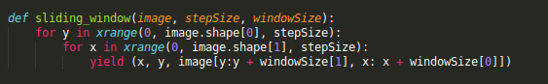
Then we iterate first over the windows at step size interval, then again over all the images in the pyramid
